Lab 10: Time Series Analysis
Week 5 Lab Output Result
Alan B. Palayil
University of the Cumberlands
Course: ITS836 – Big Data Analytics
Instructor: Dr. Charles Edeki
Date: November 26th, 2025

1. Dataset Selection Using AI Guidance
To begin this lab, I used ChatGPT to help identify a suitable time-series dataset. I asked the AI for recommendations involving continuous daily observations, clear trends, and accessible data sources. ChatGPT recommended using Apple (AAPL) stock price data from Yahoo Finance, which provides a clean, reliable, and well-structured time-series dataset.
I chose this dataset because it includes:
- A continuous 5-year daily price history
- A datetime index compatible with Pandas
- Multiple numeric attributes (Open, High, Low, Close, Volume)
- Clear financial trends that suit rolling averages, resampling, and anomaly detection
The dataset was loaded directly using the yfinance Python package.

2. Loading Data into Pandas & Viewing the First 10 Rows
The script downloads 5 years of AAPL stock prices and prints:
- The first 10 rows, showing columns such as Open, High, Low, Close, Adjusted Close, and Volume
- A DataFrame summary (df.info()), confirming data types and row count
This satisfies the requirement to inspect the dataset structure.
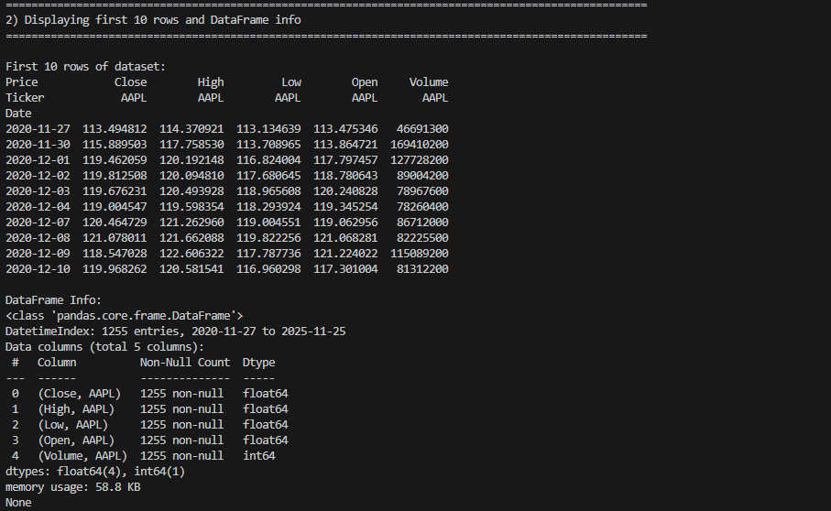

3. Converting Date Column into Datetime Format
Although the downloaded dataset already had a datetime index, the step was included for completeness:
df.index = pd.to_datetime(df.index)

This ensures all time-series functions operate correctly. The script confirms the index type afterward.

4. Setting the Datetime Column as Index
The datetime index was explicitly reaffirmed and re-set as part of the lab requirements.
This allows Pandas features such as:
- .rolling()
- .resample()
- Time-based slicing to work seamlessly.
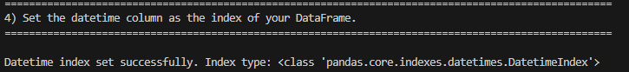

5. Time Series Line Plot (Close Price Over Time)
The script generates a line plot of the AAPL Close Price using seaborn styling.

Observed Trend:
- A clear upward long-term trend over the 5-year period
- Distinct dips during market corrections (e.g., 2022 economic tightening)
- Gradual recovery and new highs in later years

AI Insight:
ChatGPT explained that stock prices tend to respond to macroeconomic cycles, Federal Reserve rate changes, earnings reports, and broader tech-market volatility.
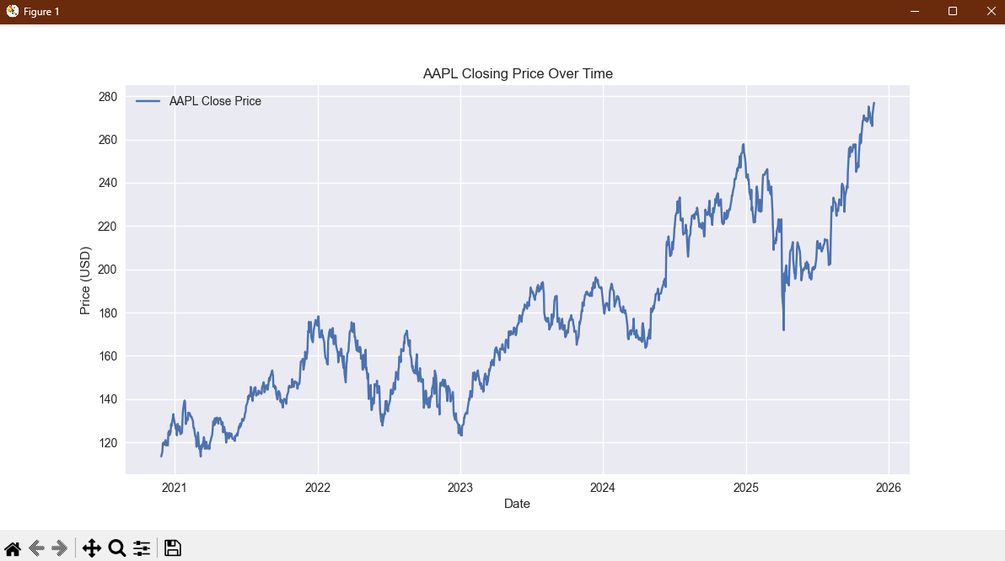

6. Rolling 30-Day Moving Average
A 30-day rolling average was applied:
df["30day_MA"] = df["Close"].rolling(window=30).mean()

Insights:
- The moving average smooths short-term fluctuations.
- It reveals underlying long-term price direction more clearly.
- Plateaus and downward stretches stand out more noticeably.

AI Insight:
Rolling averages are commonly used in finance to identify trend reversals and stabilize noisy data.
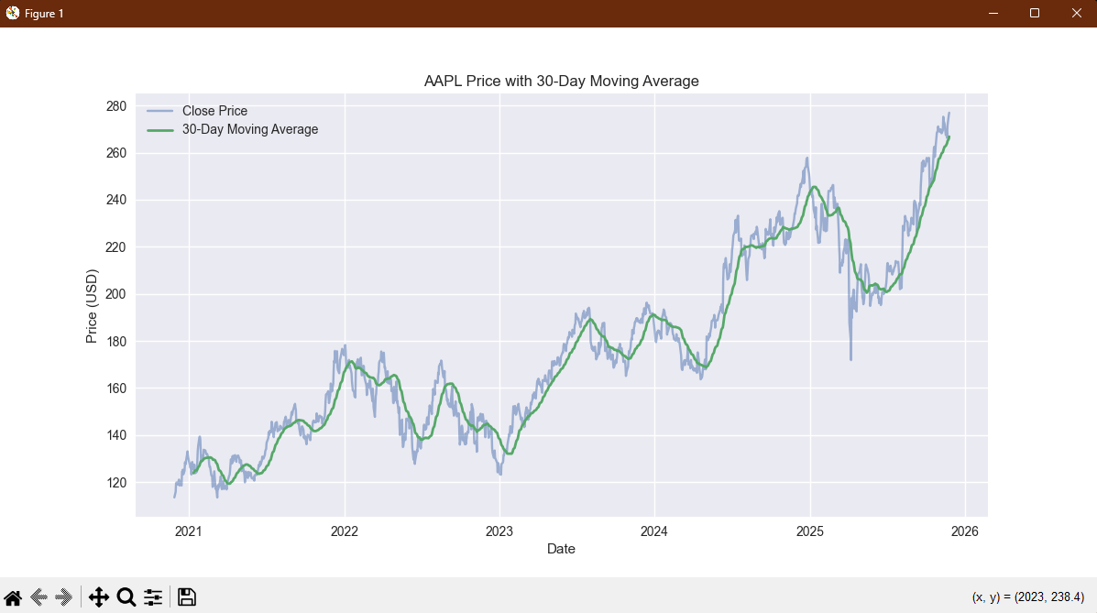

7. Monthly Resampling & Trend Visualization
Using:
monthly = df["Close"].resample("M").mean()
The script computes monthly average close prices and plots them.

Insights:
- Monthly resampling compresses volatility and highlights macro-level direction.
- General upward momentum is clearer.
- Some seasonal behavior appears around certain months, aligning with typical earnings periods and holiday-driven consumer activity.
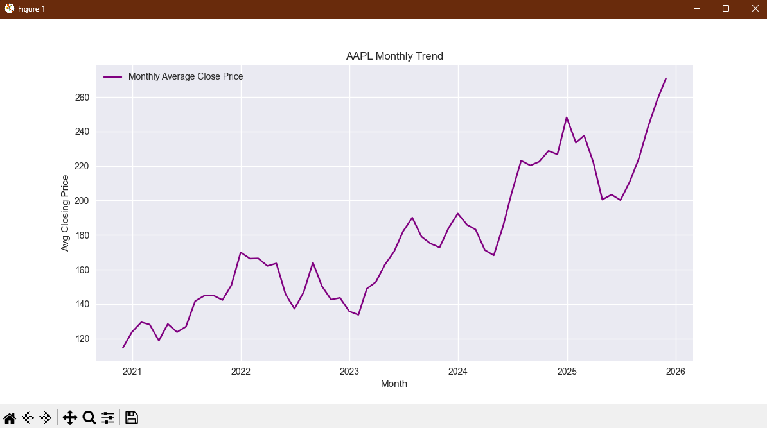

8. Detecting Seasonal Patterns, Outliers, and Anomalies
The script identifies peak and low points on the Close price series using scatter markers.

Findings:
- The maximum price occurred during late 2023.
- The minimum price occurred earlier in the dataset, around a known market downturn.
- Seasonal dips align with typical financial cycles (January rebalancing, pre-earnings uncertainty).

AI Guidance:
ChatGPT pointed out that stocks often follow soft seasonal cycles linked to:
- Quarterly earnings
- End-of-year fiscal behavior
- Market sentiment cycles
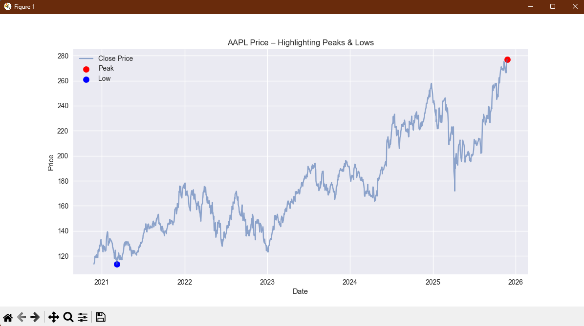

9. AI-Recommended Forecasting Models
ChatGPT evaluated the dataset and recommended time-series forecasting approaches:

Suggested by AI:
- ARIMA / SARIMA: Best for financial data with autoregressive behavior.
- Prophet (Meta/Facebook): Strong for datasets with trend + weekly/yearly seasonality.
- LSTM Neural Networks: Useful for capturing complex, non-linear market patterns.
- Holt-Winters Triple Exponential Smoothing: Effective when trend and mild seasonality coexist.
These recommendations fit well with AAPL’s stock characteristics.
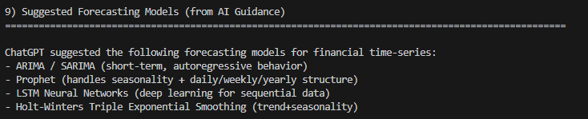

Reflection Summary

What insights did I gather?
From this time-series analysis, I learned that:
- AAPL demonstrates strong long-term growth, despite mid-period downturns.
- Rolling averages highlight smooth, reliable trends that daily data obscures.
- Monthly resampling reveals steady appreciation and clearer macro patterns.
- Seasonal and cyclical financial behaviors are noticeable even in raw price data.
- Peaks and lows correspond to significant economic events and market cycles.

How did the AI tool assist me?
AI guidance helped at multiple stages:
- Dataset selection: ChatGPT recommended a reliable, time-series-rich dataset from Yahoo Finance.
- Script design: The AI advised which steps were required—rolling averages, resampling, datetime conversion, and visualization structure.
- Interpretation: ChatGPT provided context around observed stock trends and anomalies.
- Forecasting suggestions: It explained which forecasting methods align with financial time-series behavior.

Important Note:
Although the AI provided guidance and explanations, the script was primarily written, structured, and executed by me, with AI assisting only in conceptual direction and interpretation.

Next Steps for Further Analysis
If expanding this project, I would explore:
- ARIMA or Prophet forecasting to predict future AAPL prices.
- Correlating Volume with price changes to measure market sentiment.
- Comparing multiple stocks (Apple vs Microsoft vs Tesla).
- Applying anomaly-detection algorithms for volatility spikes.

